This year, you will be able to travel with organized transport around the Kamnik-Savinja Alps. In the past years, the circular transport around the Kamnik-Savinja Alps has proven to be very welcome both among tourists and locals. Everyone is positively accepting this new form of sustainable mobility. We expect that the number of transported passengers will increase over the years.
Any valley in the Kamnik - Savinja Alps or the starting points for mountain tours will be accessible in the summer months to everyone who wants to spend some time in our beautiful mountains.
Access to Logarska dolina, Jezersko, Krvavec, Preddvor, Podvolovljek, Kamniška Bistrica will not present any problems. In the morning, the transport will take you in one direction, and in the afternoon, you will return in the opposite direction to the starting destination.
Passengers will be able to access the transport at the following stations (in the morning there will be one-way travel and in the afternoon in the other): Kamnik - bus station, Apno, Gondola Krvavec, Cerklje center, Preddvor jezero, Jezersko - bus station near the Municipality, Jezersko - bus station near the lake, Logarska dolina Plesnik, Solčava - Center Rinka, Luče - bus station, Podvolovljek - Sv. Anton, Kranjski Rak, Kamniška Bistrica - Kamnik - bus station.
The transport will be organized from 24.6.2023 to 3.9.2023, twice a day. The price of transportation varies between 4 and 9 euros. Seat reservations are possible one day before departure until 4 p.m. at the local TIC point or by calling 040/890 105. The hours of transport will be adapted to the need or passenger demand.
Use a more friendly transport option and take your friends, family or acquaintances through the beautiful landscape of the Kamnik-Savinja Alps with organized transport.
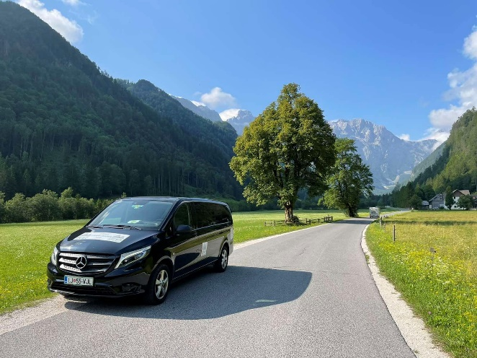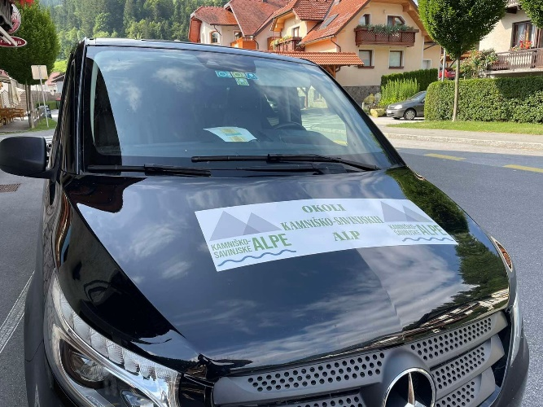
TIMETABLE
Tuesday, Thursday, Saturday

AM | STATION | PM
The beginning |  | The end
8.00 | Kamnik AP | 18.45
8.20 | Apno | 18.25
8.28 | Gondola Krvavec | 18.17
8.35 | Cerklje TIC | 18.10
8.50 | Preddvor jezero | 17.55
8.53 | Preddvor center | 17.52
9.23 | Jezersko Občina AP | 17.22
9.28 | Jezersko jezero AP | 17.17
10.20 | Logarska dolina Plesnik | 16.25
10.30 | Solčava – Center Rinka | 16.15
10.37 | Luče AP | 16.08
10.52 | Podvolovljek – Sv. Anton | 15.53
11.00 | Kranjski Rak | 15.45
11.30 | Kamniška Bistrica | 15.15
11.45 | Kamnik AP | 15.00

TIMETABLE
Monday, Wednesday, Friday, Sunday

AM | STATION | PM
The beginning |  | The end
8.00 | Kamnik AP | 18.45
8.15 | Kamniška Bistrica | 18.30
8.45 | Kranjski Rak | 18.00
8.53 | Podvolovljek – Sv. Anton | 17.52
9.08 | Luče AP | 17.37
9.15 | Solčava – Center Rinka | 17.30
9.25 | Logarska dolina Plesnik | 17.20
10.17 | Jezersko jezero AP | 16.28
10.22 | Jezersko Občina AP | 16.23
10.52 | Preddvor center | 15.53
10.55 | Preddvor jezero | 15.50
11.10 | Cerklje TIC | 15.35
11.17 | Gondola Krvavec | 15.28
11.25 | Apno | 15.20
11.45 | Kamnik AP | 15.00

